When I wrote this program the first time I had a mistake, and Ruby told me about it like this:

There are 100 cars available.

There are only 30 drivers available.

There will be 70 empty cars today.

ex4.rb:14: undefined local variable or method `carpool_capacity' for

main:Object (NameError)

Explain this error in your own words. Make sure you use line numbers and explain why.

Answer: The underscore character is placed in the wrong place; the underscore character breaks up the word “carpool,” into “car pool,” therefore does not match the remainder of the code, and keeps the program from running

1.I used 4.0 for space _in _a _car, but is that necessary? What happens if it's just 4?

Output: Floating point numbers are more accurate than integers, they are also ideal. In contrast, variables cars, drivers, and passengers, should not be represented by floating point numbers because there are **no** fractions of cars, drivers, or passengers; but there **can be** fractions of physical space in a vehicle; If space_in_a_car is just 4, it will not provide correct calculations of the physical space in a car.

2.Remember that 4.0 is a floating point number. It's just a number with a decimal point, and you need 4.0 instead of just 4 so that it is floating point.

3.Write comments above each of the variable assignments.

Output:

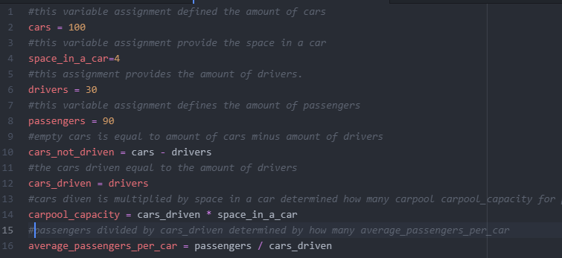

4.Make sure you know what = is called (equals) and that its purpose is to give data (numbers, strings, etc.) names (cars_driven, passengers).

5.Remember that _ is an underscore character.

6.Try running ruby from the Terminal as a calculator like you did before, and use variable names to do your calculations. Popular variable names are also i, x, and j.

Output:

